Name : KEVIN AMADIVA LUGADILU

REG NO : I39/1981/2011

DIGITAL CIRCUIT : DIGITAL COMPARATOR

**CIRCUIT THEORY:**

DIGITAL COMPARATOR is an example of a combinational logic circuit. DIGITAL COMPARATORS normally comprise of 3 standard gates i.e. AND, NOR and NOT gates which compare digital signals at their input terminals and give an output depending on the state and condition of those inputs.

Digital circuits along with the functionality of adding and subtracting binary numbers, they can also compare them and check whether the value at one input is greater or smaller than the value at the second input. Also comparing to see whether the 2 values are equal or not. A DIGITAL COMPARATOR manages to accomplish all these 3 functionalities by using the three gates that work on the principle of Boolean algebra.

**Types of Digital comparators**

There are 2 main types

**IDENTITY COMPARATOR**:

This type of comparator has only 1 output terminal for when input A=input B either the output is “High” =1 or “low” =0

**MAGNITUDE COMPARATOR**:

Magnitude comparator on the other hand has 3 output terminals, where the first handles equality i.e. input A = Input B, the second Greater than i.e. input A > Input B and the third Less than i.e. Input A < Input B.

The main aim of a DIGITAL COMPARATOR is comparing a set of unknown variables against that of a constant and output a condition or a flag depending on the result of the comparison. Taking an example of a Magnitude Comparator of 2 one-bit s (Input A and input B) would end up producing the three outputs depending on the condition i.e. A=B, A>B, A<B.

This way of comparison is useful when we want to compare 2 variables and produce an output when the above three conditions are met. E.g. produce an output from a digital counter when a specific count number is reached. An example diagram is shown below

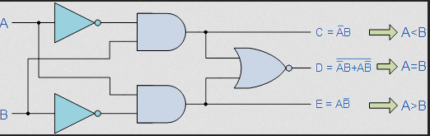

The operation of the one-bit digital comparator is given in the truth table below.

The timing diagram is as follows

INPUT A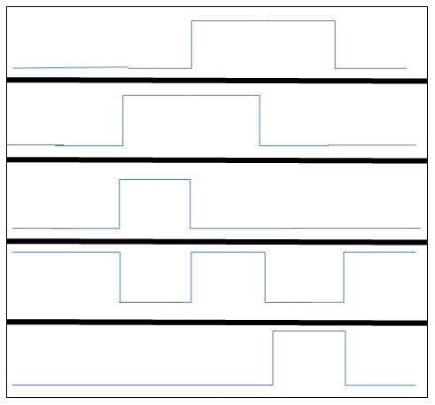

INPUT B

OUTPUT C (LESS THAN)

OUTPUT D (EQUALITY)

OUTPUT E (GREATER THAN)

From the truth table we can notice 2 distinct features of the circuit.

1. The circuit cannot distinguish between 2 “zeros (0)” and 2”ones (1)” since the output of EQUALITY (=) outputs a logic high signal for these two states.
2. The output condition for the EQUALITY output resembles that of an NOR gate with an equation

For an n-bit digital comparator e.g. the common 8 bit and 16 bit comparators, the inputs are represented as

A = (A1, A2, A3 ... An)

B = (B1, B2, B3 … Bn )

But the outputs port remain the same i.e. 3 ouputs

**A COMPARATOR IMPLEMENTSTION IN SYSTEMC**

***systemc code (coded and tested)***

*FIND THE SYSTEMC-CODE ATTACHED TO THE EMAIL*

***Results after simulation***

nivek@nivek-HP-Pavilion-dv6-Notebook-PC:~/Desktop/workin simulation$ g++ -I. -I$SYSTEMC_HOME/include -L. -L$SYSTEMC_HOME/lib-linux64 -o SIM assignment.cpp -lsystemc -lm

nivek@nivek-HP-Pavilion-dv6-Notebook-PC:~/Desktop/workin simulation$ ./SIM

SystemC 2.3.0-ASI --- Apr 26 2014 16:57:48

Copyright (c) 1996-2012 by all Contributors,

ALL RIGHTS RESERVED

WARNING: Default time step is used for VCD tracing.

Info: /OSCI/SystemC: Simulation stopped by user.

nivek@nivek-HP-Pavilion-dv6-Notebook-PC:~/Desktop/workin simulation$

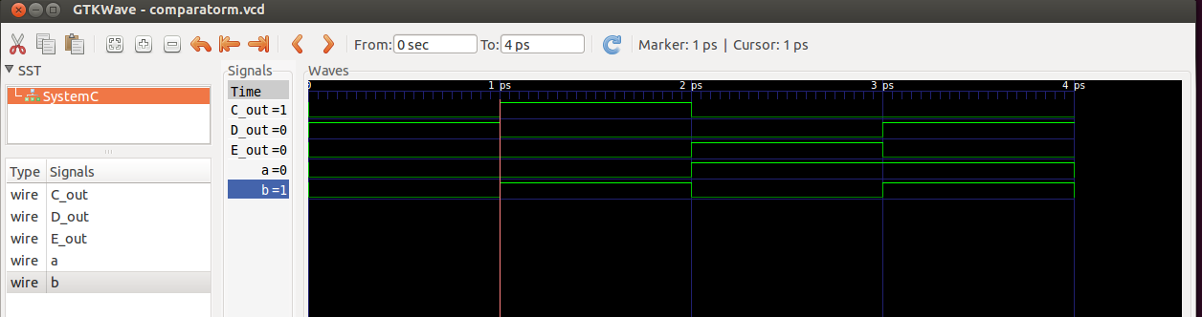

***THIS vcd FILE IS ALSO ATTACHED TO THE EMAIL***

**APPLICATION**

* When implemented as analogue comparators, they can be used to trigger various analogue systems.
* Used in temperature control when using a sensor as one input but calculated in digital domain.
* Can be used to develop digital dividers , when using a free-running counter as one comparator input and user switches as the other, an “EQUALITY” Signal will be obtained for every X counts/ Y user input count
* But Comparators are rather determined by their versatility and how they can be implemented rather than their application.
* In general comparators are widely used in Analogue-to Digital converters and Arithmetic Logic Units to perform variety of arithmetic operations.